**Loss of Biodiversity Reading**

Biodiversity is the totality of genes, species and ecosystems in a defined area. Loss of biodiversity refers to either the ongoing extinction of species at a global level or the local reduction or loss of species in a given habitat. The scale of the problem: in the last 40 years, we have lost 52% of planetary biodiversity & lost 58% of vertebrates on land, sea and air - the vertebrate figure could rise to 66% by 2020.

The answer to what causes biodiversity loss in most cases is simple. Mankind. Over 99% of species currently extinction-threatened are so because of human activity.

[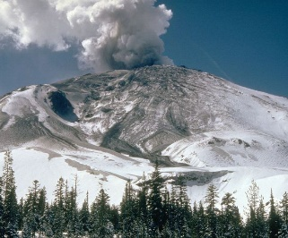](https://www.saveearth.info/s/cc_images/teaserbox_4900015.jpg?t=1495145720)

**Natural causes of biodiversity loss**

Destruction of habitat: natural forces can act to destroy habitat, species and individual organisms. Obvious examples include volcanic eruptions, floods and fire.

Previous mass extinction events have been associated with asteroid impact.

The same factors can also drive habitat fragmentation. Fragmentation can isolate populations, reduce gene pools and weaken species 'fitness' or ability to survive and reproduce.

Volcanic eruption: a case study

On May 18, 1980, a major volcanic eruption occurred at Mount St. Helens, a volcano located in Skamania County, in the state of Washington, United States.

An eruption column rose 80,000 feet (24 km; 15 miles) into the atmosphere and deposited ash in 11 U.S. states. Hundreds of square miles were reduced to wasteland. More than 4,000,000,000 board feet (9,400,000 m3) of timber was damaged or destroyed, mainly by the lateral blast.

Downwind of the volcano, in areas of thick ash accumulation, many agricultural crops, such as wheat, apples, potatoes and alfalfa, were destroyed. As many as 1,500 elk and 5,000 deer were killed, and an estimated 12 million salmon were killed.

In total Mount St. Helens released 24 megatons of thermal energy, 7 of which were a direct result of the blast. This is equivalent to 1,600 times the size of the atomic bomb dropped on Hiroshima.

Natural climate change: environmental stress applied through heat loss or drought.

Invasive species and disease: species newly introduced through natural means out-compete the local species for resources.

[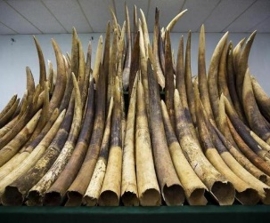](https://www.saveearth.info/s/cc_images/teaserbox_4900016.jpg?t=1495146148)

**Man-made causes of biodiversity loss**

Climate change: see [global warming pages](https://www.saveearth.info/global-warming/). Induced through man-made activities although to provide a balanced view, species can gain environmental advantage or lose it when the climate changes.

Pollution on land, in [air](https://www.saveearth.info/air-pollution/) and [water](https://www.saveearth.info/plastic-pollution/). Water systems suffer [aquatic nutrient load](https://www.saveearth.info/nitrogen-pollution/) from fertilizers and agricultural by-products. Oceans are seeing [rising acidity levels](https://www.saveearth.info/ocean-acidification/) caused by man-made pollutant activity.

Habitat destruction and degradation: mining, agriculture, settlement, industries, highways and construction being primary examples. Degradation casued through [poor land use](https://www.saveearth.info/land-degradation/) and [deforestation](https://www.saveearth.info/deforestation/).

Habitat fragmentation: fragmentation is one of the most serious causes of erosion of biodiversity. Fragmentation leads to artificially created ‘terrestrial islands’ with microclimatic effects markedly different from those that existed in the large tracks of habitats before fragmentation.

Over-exploitation: overfishing has reduced some commercial fish stocks by more than 90%.

Introduction of invasive (aka 'exotic') species: any species which is not a natural inhabitant of the locality but is deliberately or accidentally introduced into the system may be designated as an exotic species. Native species are subjected to competition for food and space due to the introduction of exotic species.

There are many well-documented extinctions caused by the introduction of exotic species.

The introduction of Nile perch to Lake Victoria, Africa’s largest lake, has driven almost half of the 400 original fish species of the lake to near extinction.

[Human overpopulation](https://www.saveearth.info/human-overpopulation/): humans may be considered the 'worst-case' exotic species for most organisms. Human activity and an increasingly 'consumption-intensive' lifestyle means that future human population growth spells disaster going forward unless attitudes, behaviours and lifestyles change.

Recreational hunting and collecting: hides, skin, tusk, meat, fur, chemical content taken for monetary or aesthetic value or simply ego in the case of hunting with no purpose other than the thrill of the kill.

In the last decade, over one third of African elephants have been killed by hunters and poachers to fuel the ivory trade.

Fashion: fur clothing and reptile skins for bags and accessories are just two of the more obvious fashion-driven pressures on the natural world.

Medicinal or traditional medicinal demand: traditional medicines often drive significant demand for animal and plant material which can only be obtained by killing the providing lifeform.

Rhino horn is highly prized in Asian cultures for its claimed medicinal properties. Unfortunately, Rhino poaching is now pushing Rhino populations to the brink of extinction.

[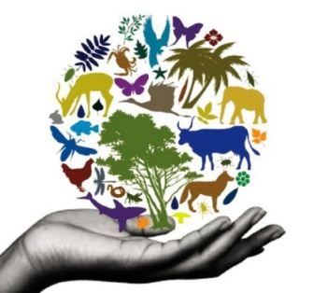](https://www.saveearth.info/s/cc_images/teaserbox_5206553.jpg?t=1496252671)